E-commerce Product Analysis Using Apache Spark

Group Members
- Taimoor Zulfiqar 2023-ag-9685
- Kannaz Shafqat 2023-ag-9558
Project Overview
This project performs E-commerce data analysis using Apache Spark (PySpark) in a Jupyter Notebook environment. The dataset contains online retail transaction records including product details, quantity, price, and country information.
The goal of this project is to:
- Load and process CSV dataset using PySpark
- Perform data cleaning and transformation
- Identify the most expensive product
- Analyze product distribution by country
- Export results as CSV files

Tools & Technologies
Tool | Purpose
Anaconda | Python environment management
PySpark | Big data processing
Jupyter Notebook | Interactive development
Python 3 | Programming language
pandas | Export results to CSV

Dataset Information
- Dataset Source: Kaggle (Online Retail Dataset)
- File Used: Ecommerce.cv

Columns Description
Column | Description
InvoiceNo | Invoice number
StockCode | Product code
Description | Product name
Quantity | Number of items purchased
InvoiceDate | Date of purchase
UnitPrice | Price per unit
CustomerID | Customer ID
Country | Country of purchase

Project Tasks

Task 1 — Load Dataset
The dataset is loaded into a Spark DataFrame using SparkSession
Output Screenshot:
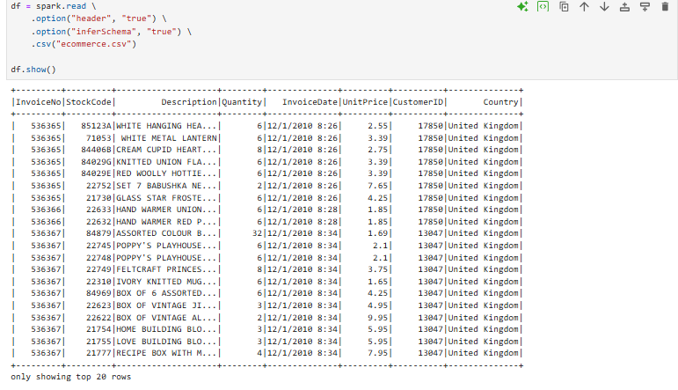

Task 2 — Most Expensive Product
The product with the highest UnitPrice is identified using sorting.
Output Screenshot:
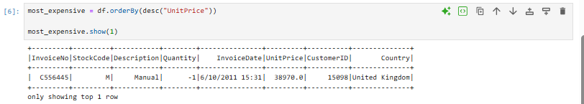

Task 3 — Group by Country
Products are grouped based on country to analyze distribution.
Output Screenshot:
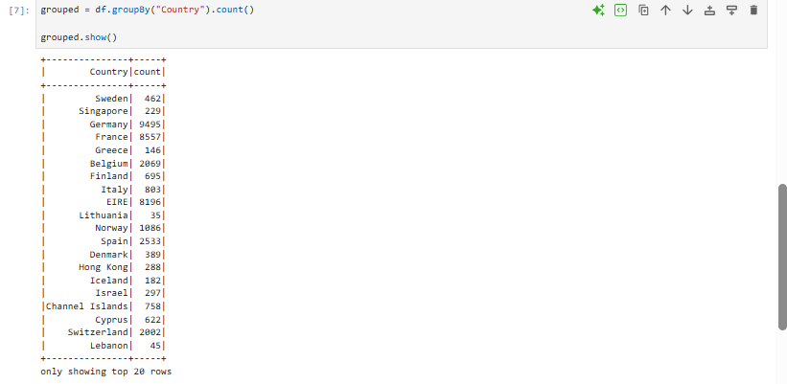

Task 4 — Count Products Per Country
Total number of products sold per country is calculated.
Output Screenshot:
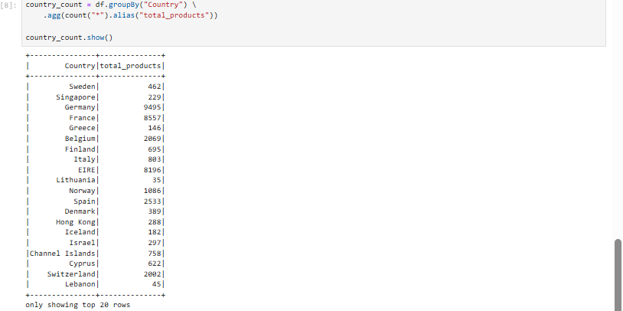

Task 5 — Export Output Files
Final results are saved into CSV files.
Output Screenshot (Folder View):
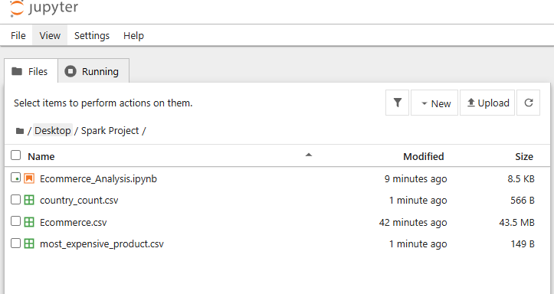

Code Summary

Load Dataset
df = spark.read \
.option ("header", "true") \
.option("inferSchema", "true") \
.csv("data.csv")

Most Expensive Product
from pyspark.sql.functions import desc

most_expensive = df.orderBy(desc("UnitPrice"))
most_expensive.show(1)

Group By Country
country_count = df.groupBy("Country").count()
country_count.show()

Save Output Files
country_count.toPandas().to_csv("output/country_count.csv", index=False)

most_expensive.limit(1).toPandas().to_csv(
"output/most_expensive_product.csv",
index=False
)

Output Files
File Name | Description
country_count.csv | Product count per country
most_expensive_product. | Highest priced product

Learning Outcomes
- Learned PySpark DataFrame operations
- Performed real-world data analysis
- Used groupBy and aggregation functions
- Exported processed data to CSV
- Understood big data processing basics

Conclusion
This project demonstrates how Apache Spark can efficiently process large-scale e-commerce data. Using PySpark, we performed data loading, transformation, aggregation, and extracted useful business insights such as the most expensive product and country-wise sales distribution.

